Experiment-4

⬛ Aim
To analyze the performance of a Logistic Regression model using a numerical dataset by calculating model weights, predictions, accuracy, and confusion matrix using Python.

⬛ Algorithm
- Choose a numerical binary dataset.
- Preprocess data (add bias column).
- Initialize weights to zero.
- Apply sigmoid function to convert linear output into probabilities.
- Train using Gradient Descent:
  - Compute predictions
  - Update weights using gradients
- Predict class labels (≥ 0.5 → 1, else 0)
- Compute:
  - Accuracy
  - Confusion matrix (TP, TN, FP, FN)
- Display performance results.

⬛ Input
X (study hours): [1, 2, 3, 4, 5, 6]
Y (pass/fail): [0, 0, 0, 1, 1, 1]

⬛ Output
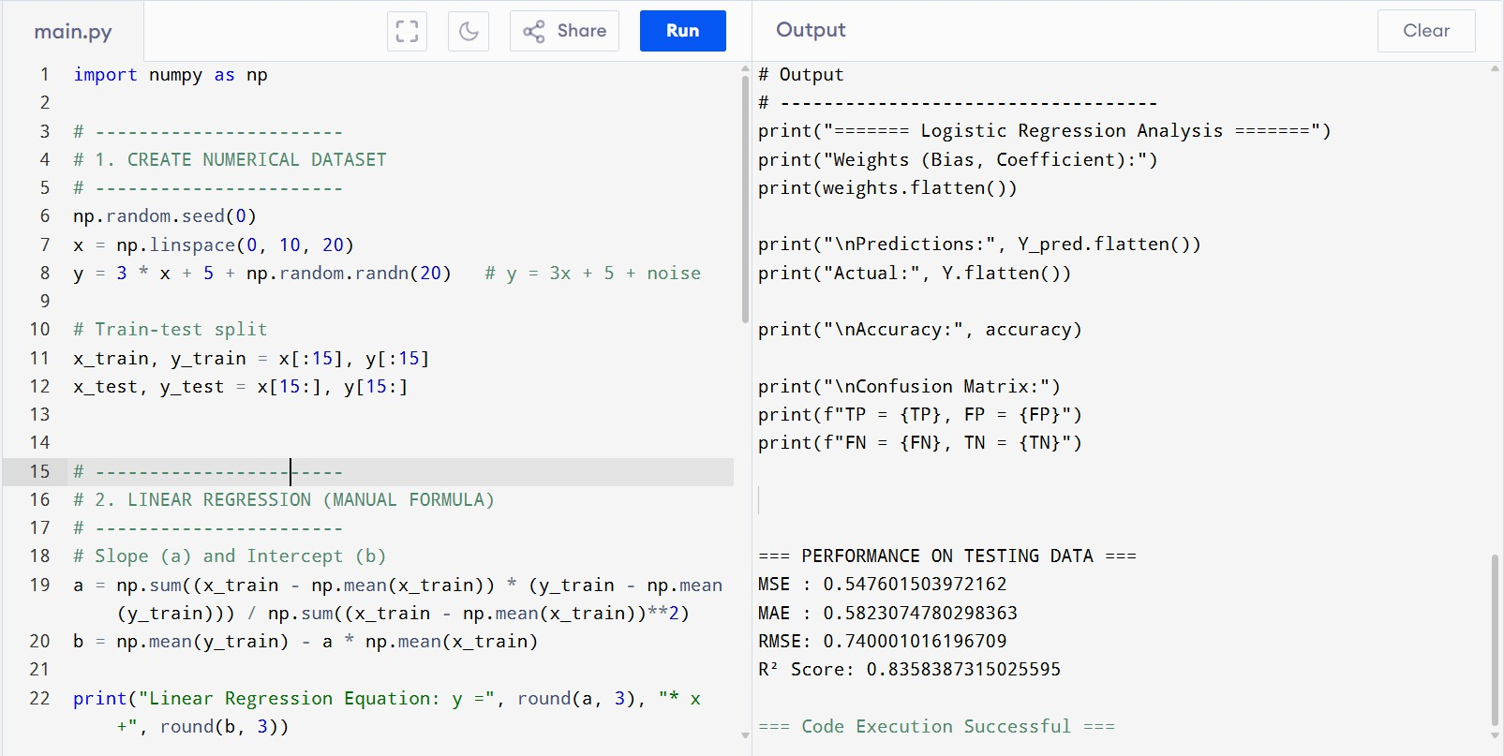

⬛ Result
The logistic regression model successfully separates the data into two classes with 100% accuracy for the chosen dataset.
The confusion matrix shows perfect classification with no misclassifications.

